How to Setup Skype for Business on a Mac

- Open Finder>

- Find and Open Skype for business>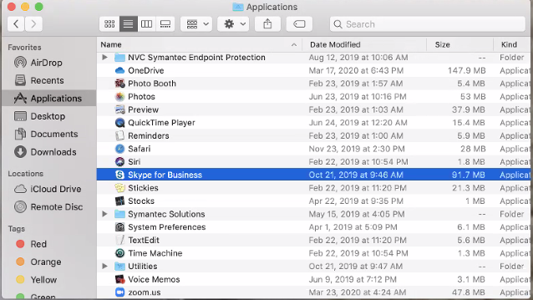

- Type @alamo.edu email address then Advanced Options
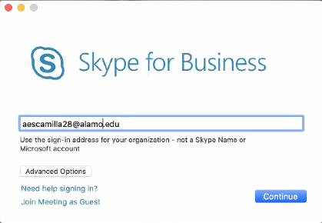

- Under Advanced Options> Type root\username then hit the “save” button.
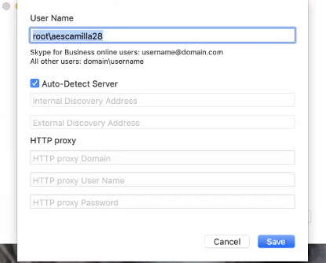

- Type email password to Sign in you can find this in Aces under Employee>Web Services>Employee>View Email Password.

