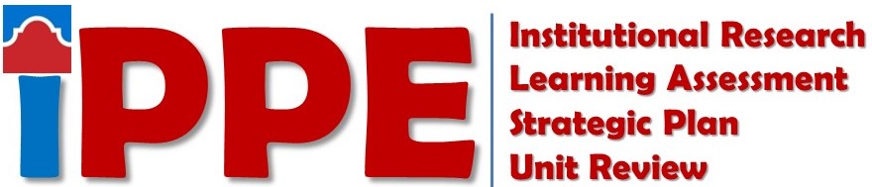
Fall 2021
SAC SCORES Submission Checklist
Items listed below must be submitted to the SAC SCORES file site by 5 p.m. 9/24/2021

STUDENT SUCCESS
Staff
☐ Institutional Research: Use of Data Form Online - Non-Academic (individual link in email)
Directors and Department Leads
☐ Institutional Research: Use of Data Form Online – Non-Academic (individual link in email)
☐ Learning Assessment: Learning Assessment Reflection – Student Success Form
☐ Strategic Planning: Strategic Plan
☐ Strategic Planning: Strategic Planning Outcomes Analysis

ACADEMIC SUCCESS
Faculty
☐ Institutional Research: Use of Data Form – Faculty
☐ Learning Assessment: SLO by Term Report (For discipline meeting only, Do Not Upload to site)
Staff
☐ Institutional Research: Use of Data Form Online – Non-Academic (individual link in email)
Program Coordinators/Discipline Assessment Representatives
☐ Institutional Research: Use of Data Form – Rubric
☐ Institutional Research: Use of Data Form – Program
☐ Learning Assessment: Learning Assessment Reflection – Academic Success Form
- (AA, AS, AAT, AAT, CORE – Primarily Arts & Science disciplines)
☒ Learning Assessment: Learning Assessment Reflection – Academic Success Form
- (AAS – Primarily CTE disciplines) ONE FOR EACH DEGREE
☐ Learning Assessment: Discipline Assessment Validation Process Form
☐ Strategic Planning: Strategic Plan
☐ Strategic Planning: Strategic Planning Outcomes Analysis
Chairs/Directors/Coordinators
☐ Strategic Planning: Strategic Plan
☐ Strategic Planning: Strategic Planning Outcomes Analysis

COLLEGE SERVICES
Staff
☐ Institutional Research: Use of Data Form Online - Non-Academic (individual link in emailed)
Directors and Department Leads
☐ Institutional Research: Use of Data Form Online - Non-Academic (individual link in emailed)
☐ Strategic Planning: Strategic Plan
☐ Strategic Planning: Strategic Planning Outcomes Analysis

For SAC SCORES Assistance Contact
Strategic Planning Forms  Ester Coronado  SAC-STRATEGICPL@ALAMO.EDU | Institutional Research Forms  Savithra Eratne  SERATNE@ALAMO.EDU | Learning Assessment Forms  Rosalind Ong  SAC-SLOS@ALAMO.EDU

