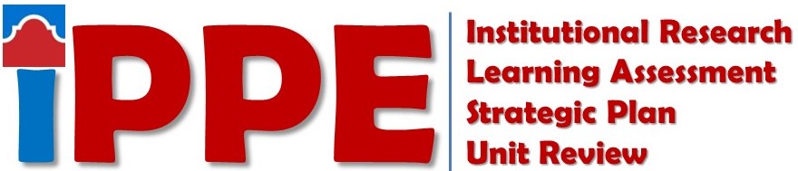
Spring 2021
SAC SCORES Submission Checklist
Items listed below must be submitted to the SAC SCORES file site by 5 p.m. 3/19/2021

STUDENT SUCCESS
Staff
☐ Institutional Research: Use of Data Form - Non Academic
Directors and Department Leads
☐ Institutional Research: Use of Data Form - Non Academic
☐ Learning Assessment: Learning Assessment Reflection – Student Success Form
☐ Learning Assessment: Backward Design File
☐ Learning Assessment: Student Success SSLO Assessment(s)
☐ Strategic Planning: Strategic Plan
☐ Strategic Planning: Strategic Planning Outcomes Analysis

ACADEMIC SUCCESS
Faculty
☐ Institutional Research: Use of Data Form – Faculty
Staff
☐ Institutional Research: Use of Data Form – Non-Academic
Program Coordinators/Discipline Assessment Representatives
☐ Institutional Research: Use of Data Form – Rubric
☐ Institutional Research: Use of Data Form – Program (CTE/PTE Only)
☐ Learning Assessment: Learning Assessment Reflection – Academic Success Form (A&S or CTE/PTE)
☐ Strategic Planning: Strategic Plan
☐ Strategic Planning: Strategic Planning Outcomes Analysis
Chairs/Directors/Coordinators
☐ Strategic Planning: Strategic Plan
☐ Strategic Planning: Strategic Planning Outcomes Analysis

COLLEGE SERVICES
Staff
☐ Institutional Research: Use of Data Form - Non Academic
Directors and Department Leads
☐ Institutional Research: Use of Data Form - Non Academic
☐ Strategic Planning: Strategic Plan
☐ Strategic Planning: Strategic Planning Outcomes Analysis

For SAC SCORES Assistance Contact
Strategic Planning Forms  Ester Coronado  Sac-strategicpl@alamo.edu | Institutional Research Forms  Savithra Eratne  Seratne@alamo.edu | Learning Assessment Forms  Rosalind Ong  Sac-slos@alamo.edu

