Email Etiquette for Students
When it comes to emailing professors, suitable communication can seem a bit intimidating because you may not know what or how to write to them. You certainly do not want to sound as though you are emailing a friend, but you are not a colleague to your professor, either. Nonetheless, you want to be as professional as possible when writing. Below are some helpful tips on how to construct a professional email, the do’s and don’ts of an email, and how to respond.

When constructing a professional email:
- Be sure you have the correct email address of the person you are trying to get in touch with. Many times, a person may jot down the wrong email information, so be sure to pay attention to the information you are taking down, so that there is no confusion upon emailing the person.
- Include any other email address of those who also need to be informed of what you are going to say in the email. For example, suppose you are in a group project, and your partners need to be informed that you will be running late. In this case, you will add their email address in the section marked cc, which is located below the person you are initially emailing your information to. In this case, it would most likely be your professor.
- Include a proper subject line that indicates what your email is about; this helps the recipient prioritize reading your email.
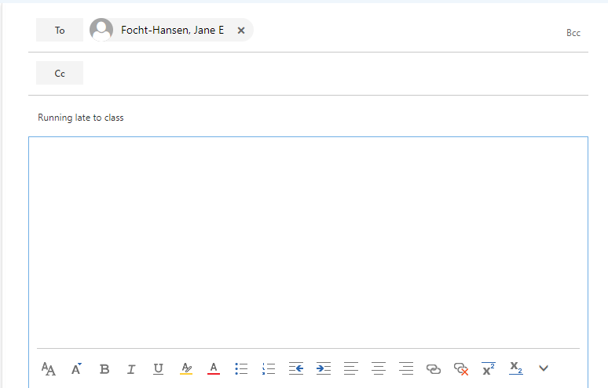
  - EX:
This is the subject line where you will write what the email is about.
This is where you will write the email address of the person you are trying to reach.
This is where you will add any other people on the email, who need to be informed of the information you will be giving.

- Be sure to open your email with a greeting like Dear Dr., Professor, Mr., Ms., or Mrs.
  - EX: 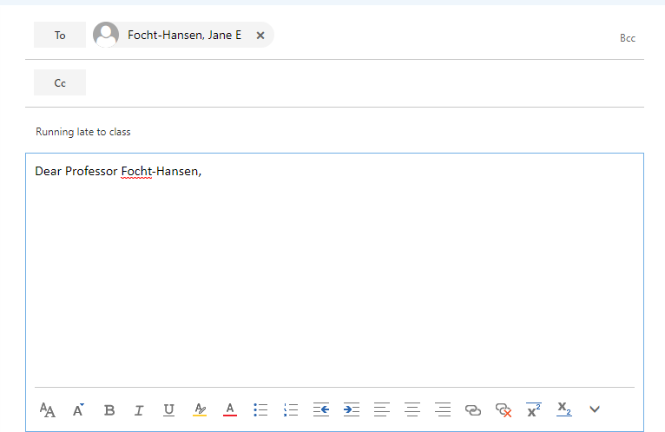
This is where you will begin writing your email. Start by greeting the recipient of the email. Most likely, it will be your professor. Next, be as specific as possible when addressing who you are. Professors have several emails to sift through, so it helps to put your first and last name, the name of the and time of the class, so the professor gets an idea of who you are. This will be beneficial in the long run, so that you develop rapport with your professor.

USE: Standard spelling, punctuation, and capitalization.

BE: Clear, direct, and to the point; professionals and academics alike see their email accounts as business. Be friendly and cordial, but don't try to joke around (jokes and witty remarks may be inappropriate and, more commonly, may not come off appropriately in email)
INCLUDE: A signature block that contains the necessary information for someone to reach you should a reply be necessary and/or expected; typical closings include a sign off phrase (best, thanks, sincerely) and the sender's name. Additional information may be included when appropriate (department, office location, or position).

- EX:
Be as detailed as possible when stating the reason for the email. See above, the student stated the reason for the email is because they are running late to class. They didn’t state a reason for running late, however, they did inform the professor that they would not be on time for class. Try to give as much detail as possible, so that your professor can take the appropriate action.
Close the email out with a signature closing. Here, the student closed off the email using “Thank you.” Try using a closing that best fits the email.
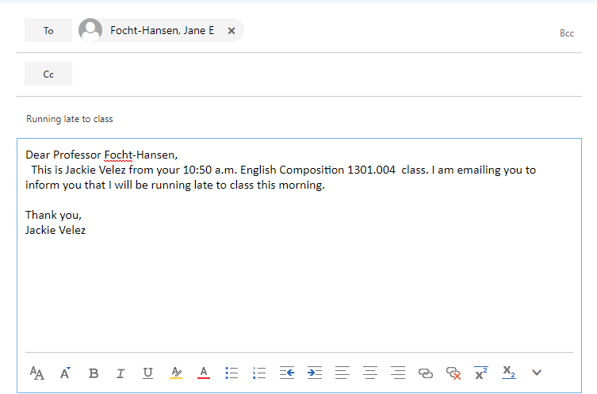

DO NOT SEND:
- Text abbreviations:
  - Example: u instead of you
- Emails in all caps.
  - THERE'S NOTHING WORSE THAN AN EMAIL SCREAMING A MESSAGE
- Unnecessarily long emails or otherwise waste the recipient's time
- Usernames and passwords
- Credit card or other account information
ADDITIONALLY: Avoid sensitive or information that could potentially damage someone's career and/or reputation, including your own. Beyond email's general lack of security and confidentiality, your recipient can always accidentally hit the Forward button, leave their email account open on a computer, or print and forget that they've printed a copy of your email.
RESPONDING: Once you have exchanged emails with a person on a given subject, it is probably acceptable to leave greetings out of your follow-up emails. Here are some other points to consider about continuing conversations over email:

- Try to respond within a reasonable time frame, though "reasonable" will depend on the recipient's expectations and the subject being discussed
- Trim back the old messages: most email clients will keep copying older messages to the bottom of an email. Delete older messages to keep your message size from getting too large, as well as to keep your messages looking clean.
- If someone asks a lot of questions, it may be OK to embed your answers into the sender's message copied at the bottom of your email. However, if you're going to do this, be sure to say so at the top, and leave generous space, for example:

  - How long are you staying?
Less than two weeks.

  - Will you have time to visit with us?
I'm really hoping to, but my schedule will be pretty tight. Let me get back to you about that after the weekend.

These are just a few tips to provide a more professional way to communicate with your professor through email. As such, if you need any further assistance, the SAC Writing Center tutors are always available to help.

